**Lightest and Heaviest—*Sorting Algorithms***

**Summary**

Computers are often used to put lists into some sort of order, for example names into alphabetical order, appointments or e-mail by date, or items in numerical order. Sorting lists helps us find things quickly, and also makes extreme values easy to see. If you sort the marks for a class test into numeric order, the lowest and highest marks become obvious.

If you use the wrong method, it can take a long time to sort a large list into order, even on a fast computer. Fortunately, several fast methods are known for sorting. In this activity children will discover different methods for sorting, and see how a clever method can perform the task much more quickly than a simple one.

**Curriculum links**

* Mathematics: Measurement Level 2 and up. Carrying out practical weighing tasks.

**Skills**

* Using balance scales
* Ordering
* Comparing

**Ages**

* 8 and up

**Materials**

* Each group of children will need:
* Sets of 8 containers of the same size but different weights (e.g. milk cartons or film canisters filled with sand)
  + Sand can cause a mess if the containers accidentally open, so you may want to consider using something else such as pennies, or Nerds candy.
* Balance scales
* Worksheet Activity: Sorting weights (page 66)
* Worksheet Activity: Divide and conquer (page 67)

**Discussion**

Computers often have to sort lists of things into order. Brainstorm all the places where putting things into order is important. What would happen if these things were not in order?

Computers usually only compare two values at once. The activity on the next page uses this restriction to give children an idea of what this is like.

**Activity**

1. Divide the children into groups.
2. Each group will need a copy of the activity sheet on page 66, and its own weights and scales.
   1. To save time, you can do step 1 of the student activity beforehand so that the students do not have to fill the containers themselves.
   2. It can be useful to randomly label the containers beforehand (i.e. with colors or letters) so that the students have an easier time figuring out which ones they need to compare.
      1. If you are working with visually impaired students, you can put braille labeling on the containers to differentiate them.
3. Have the children do the activity, then discuss the result.

**Worksheet Activity: Sorting Weights**

**Aim:** To find the best method of sorting a group of unknown weights into order. **You will need:** A material to fill the containers with, 8 identical containers, a set of balance scales **What to do:**

1. Fill each container with a different amount of sand or water. Seal tightly.

2. Mix them up so that you no longer know the order of the weights.

3. Find the lightest weight. What is the easiest way of doing this?

**Note:** You are only allowed to use the scales to find out how heavy each container is. Only two weights can be compared at a time.

4. Choose 3 weights at random and sort them into order from lightest to heaviest using only the scales. How did you do this? What is the minimum number of comparisons you can make? Why?

5. Now sort all of the objects into order from lightest to heaviest.

When you think you have finished, check your ordering by re-weighing each pair of objects standing together.

**Selection Sort**

One method a computer might use is called selection sort. This is how selection sort works. First find the lightest weight in the set and put it to one side. Next, find the lightest of the weights that are left, and remove it. Repeat this until all the weights have been removed.

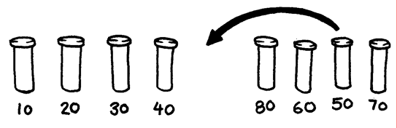

Figure : Diagram of a Selection Sort

Count how many comparisons you made.

**Extra for Experts:** Show how you can calculate mathematically how many comparisons you need to make to sort 8 objects into order. What about 9 objects? 20?

**Worksheet Activity: Divide and Conquer**

**Quicksort**

Quicksort is a lot faster than selection sort, particularly for larger lists. In fact, it is one of the best methods known. This is how quicksort works.

Choose one of the objects at random, and place it on one side of the balance scales.

Now compare each of the remaining objects with it. Put those that are lighter on the left, the chosen object in the middle, and the heavier ones on the right. (By chance you may end up with many more objects on one side than on the other.)

Choose one of the groups and repeat this procedure. Do the same for the other group. Remember to keep the one you know in the centre.

Keep repeating this procedure on the remaining groups until no group has more than one object in it. Once all the groups have been divided down to single objects, the objects will be in order from lightest to heaviest.

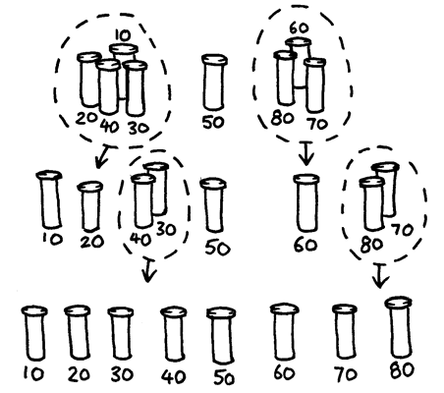

Figure : Diagram of a Quick Sort

How many comparisons did this process take?

You should find that quicksort is a more efficient method than selection sort unless you happen to have chosen the lightest or heaviest weight to begin with. If you were lucky enough to have chosen the middle weight, you should have taken only 14 comparisons, compared with the 28 for selection sort. At any rate the quicksort method will never be any worse than selection sort and may be much better!

**Extra for Experts:** If quicksort accidentally always chose the lightest object, how many comparisons would it use?

**Variations and extensions**

Many different methods for sorting have been invented. You could try sorting your weights using these:

*Insertion sort* works by removing each object from an unsorted group and inserting it into its correct position in a growing list (see picture below). With each insertion the group of unsorted objects shrinks and the sorted list grows, until eventually the whole list is sorted. Card players often use this method to sort a hand into order.

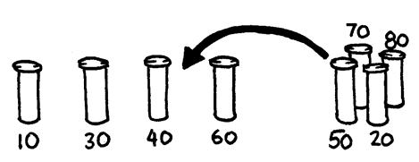

Figure : Diagram of an Insertion Sort

*Bubble sort* involves going through the list again and again, swapping any objects side- by-side that are in the wrong order. The list is sorted when no swaps occur during a pass through the list. This method is not very efficient, but some people find it easier to understand than the others.

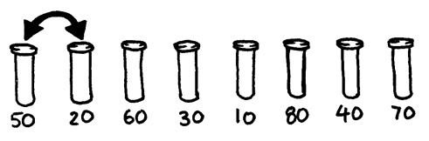

Figure : Diagram of a Bubble Sort

*Mergesort* is another method that uses ‘divide and conquer’ to sort a list of items. First, the list is divided at random into two lists of equal size (or nearly equal if there are an odd number of items). Each of the two half-size lists is sorted, and the two lists are merged together. Merging two sorted lists is easy—you repeatedly remove the smaller of the two items at the front of the two lists. In the figure below, the 40 and 60-gram weights are at the front of the lists, so the next item to add is the 40-gram weight. How do you sort the smaller lists? Simple—just use mergesort! Eventually, all the lists will be cut down into individual items, so you don’t need to worry about knowing when to stop.

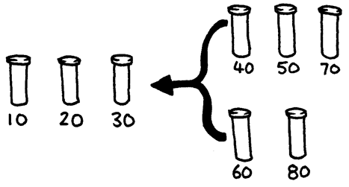

Figure : Diagram of a Mergesort

**What’s it all about?**

Information is much easier to find in a sorted list. Telephone directories, dictionaries and book indexes all use alphabetical order, and life would be far more difficult if they didn’t. If a list of numbers (such as a list of expenses) is sorted into order, the extreme cases are easy to see because they are at the beginning and end of the list. Duplicates are also easy to find, because they end up together.

Computers spend a lot of their time sorting things into order, so computer scientists have to find fast and efficient ways of doing this. Some of the slower methods such as insertion sort, selection sort and bubble sort can be useful in special situations, but the fast ones such as quicksort are usually used.

Quicksort uses a concept called recursion. This means you keep dividing a list into smaller parts, and then performing the same kind of sort on each of the parts. This particular approach is called *divide and conquer*. The list is divided repeatedly until it is small enough to conquer. For quicksort, the lists are divided until they contain only one item. It is trivial to sort one item into order! Although this seems very involved, in practice it is dramatically faster than other methods.

**Solutions and hints**

1. The best way to find the lightest weight is to go through each object in turn, keeping track of the lightest one so far. That is, compare two objects, and keep the lighter one. Now compare that with another, keeping the lighter from the comparison. Repeat until all the objects have been used.
2. Compare the weights on the balance scales. This can easily be done with three comparisons, and sometimes just two will suffice—if the children realize that the comparison operator is transitive (that is, if A is lighter than B and B is lighter than C, then A must be lighter than C).

**Experts:**

Here is a short cut for adding up the number of comparisons that selection sort makes.

To find the minimum of two objects you need one comparison, three needs two, four needs three, and so on. To sort eight objects using selection sort takes 7 comparisons to find the first one, six to find the next, five to find the next and so on. That gives us:

7 + 6 + 5 + 4 + 3 + 2 + 1 = 28 comparisons.

*n* objects will take 1 + 2 + 3 + 4 *+…* + *n –* 1 comparisons to sort. Adding up these numbers is easy if we regroup them.

For example, to add up the numbers 1 + 2 + 3 + … + 20, regroup them as

(1 + 20) + (2 + 19) + (3 + 18) + (4 + 17) + (5 + 16) + (6 + 15) + (7 + 14) + (8 + 13) + (9 + 12) + (10 + 11)

= 21 × 10

= 210

In general, the sum 1 + 2 + 3 + 4 … + *n* – 1 = *n*(*n –* 1)/2.